Coding Assessment(13-12-2023)

1.Querying Data by Using Joins and Subqueries

create table students(id int,name varchar(20),class int,marks int);

insert into students values(1,'rahul',8,45),

(2,'sai',8,65),(3,'ganesh',10,75),(4,'ram',8,85),(5,'shankar',6,55);

Inner join:

select students.id,students.name,students.class,students.marks,grades.grade

from students inner join grades on students.id=grades.id;

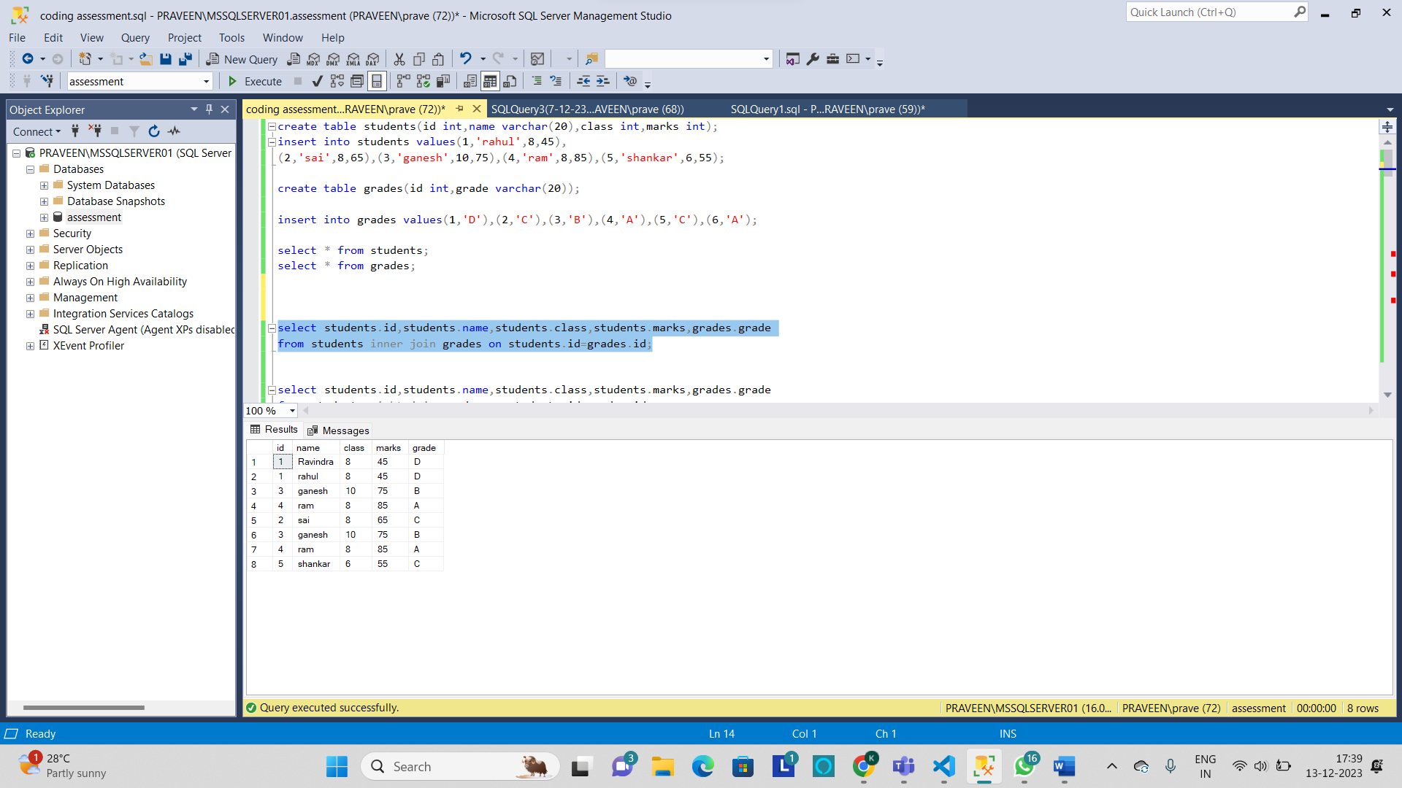

Right join:

select students.id,students.name,students.class,students.marks,grades.grade

from students right join grades on students.id=grades.id;

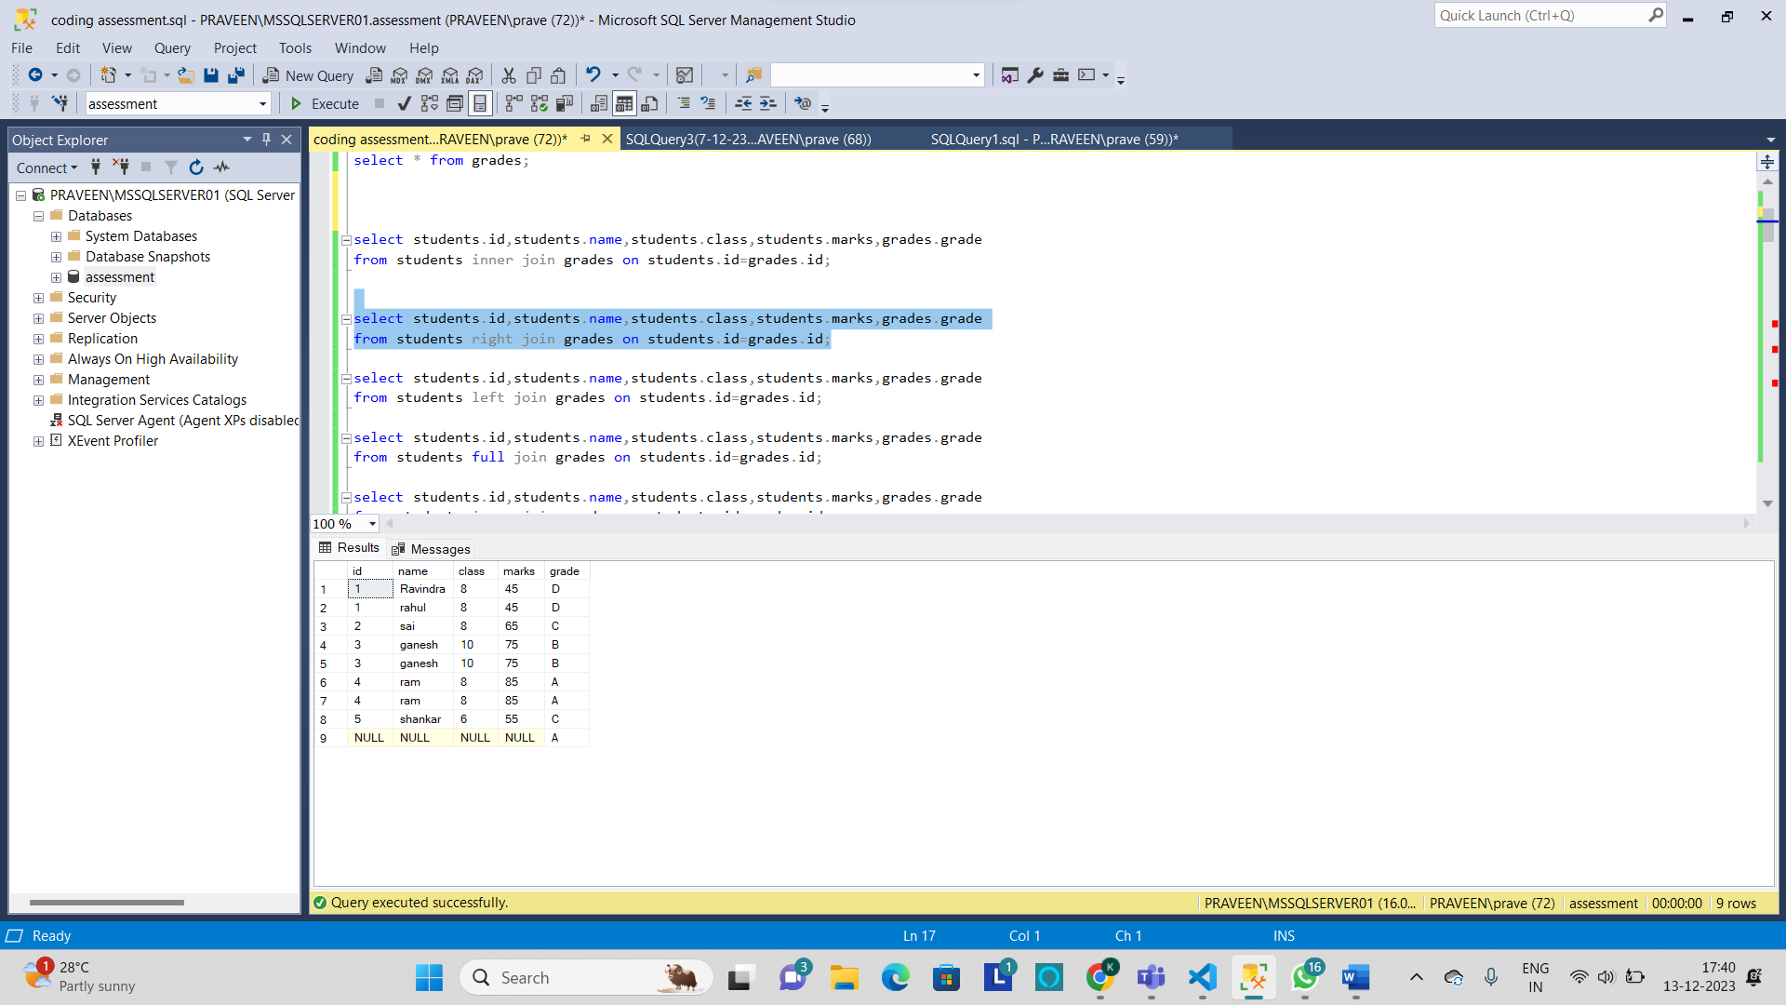

Left join:

select students.id,students.name,students.class,students.marks,grades.grade

from students left join grades on students.id=grades.id;

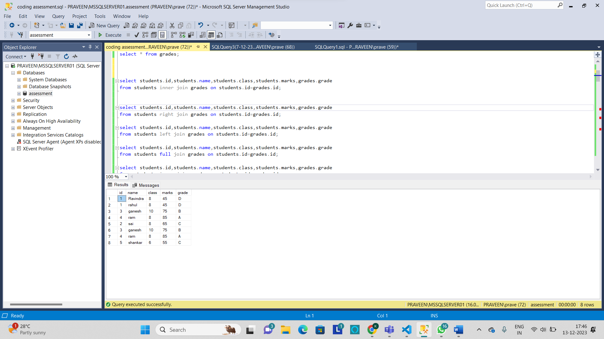

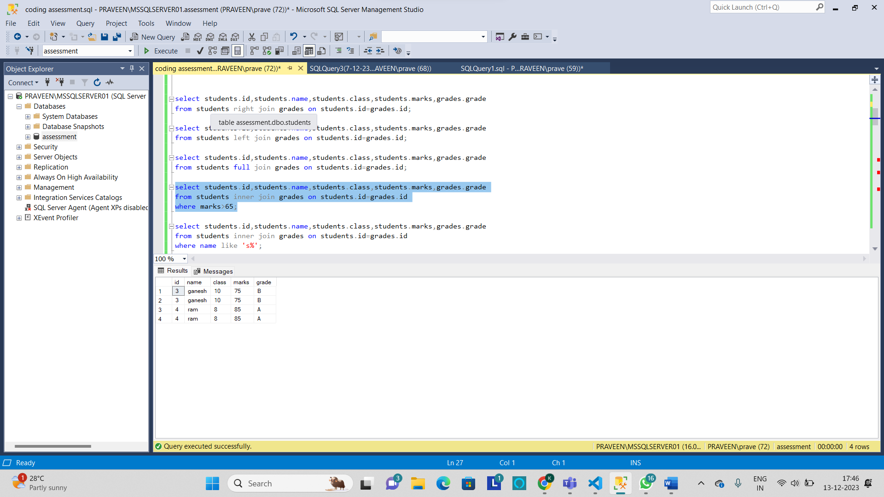

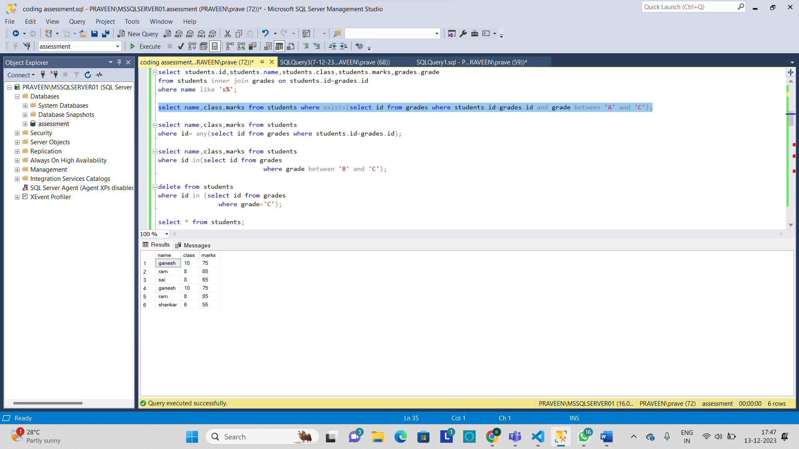

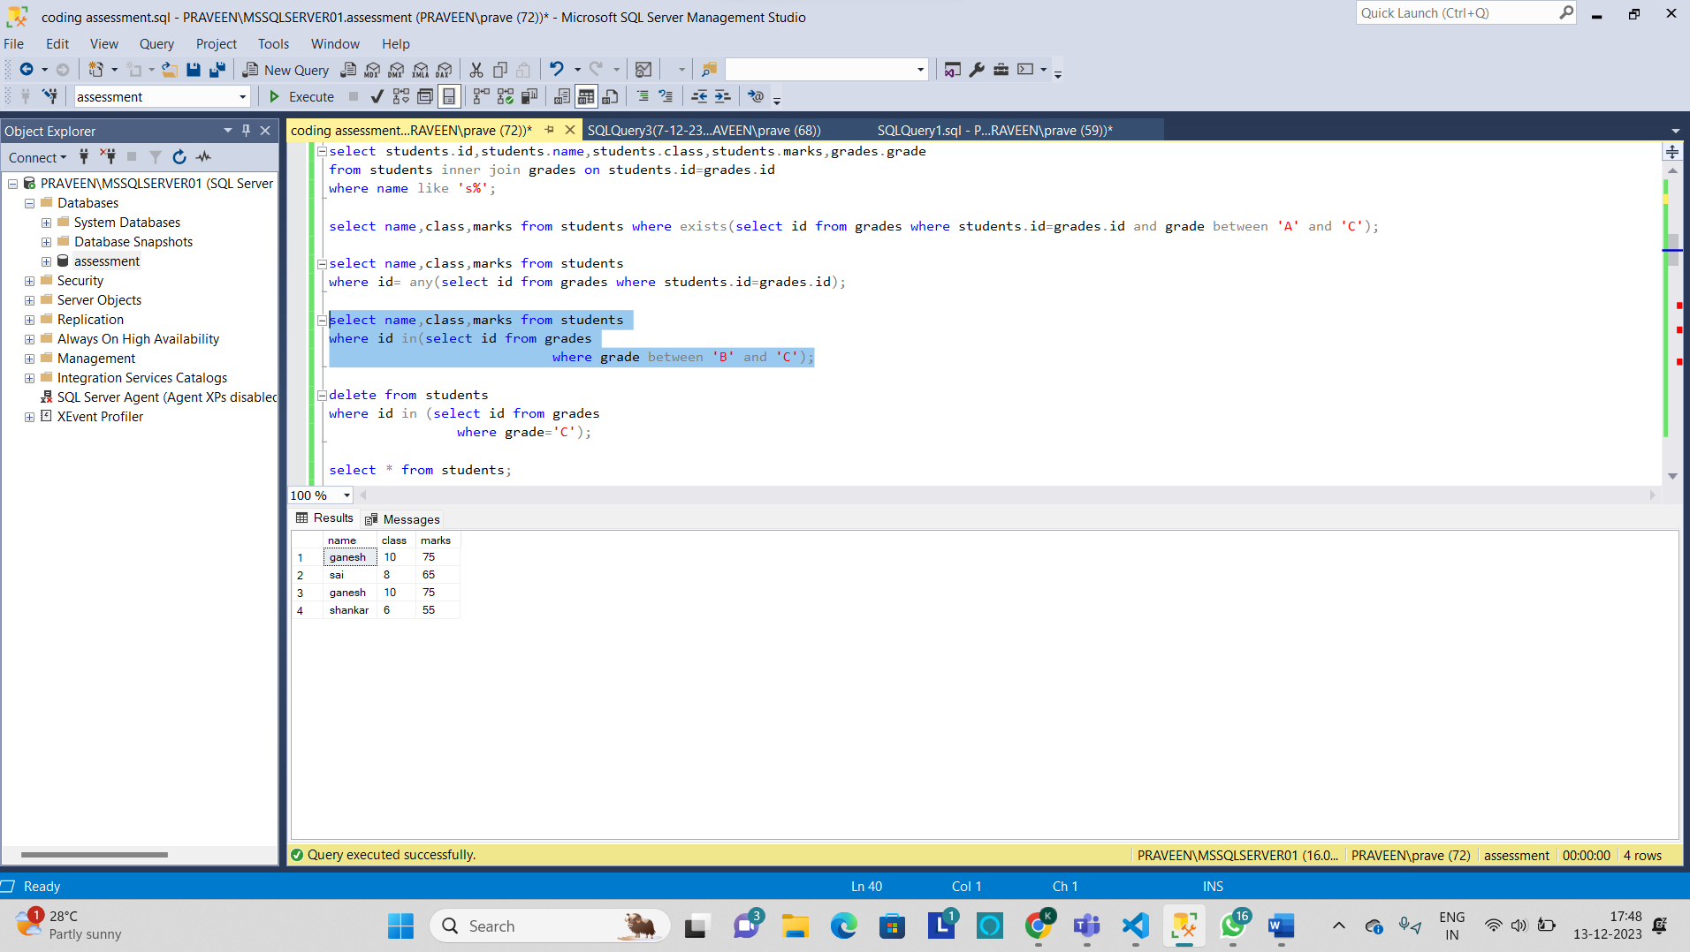

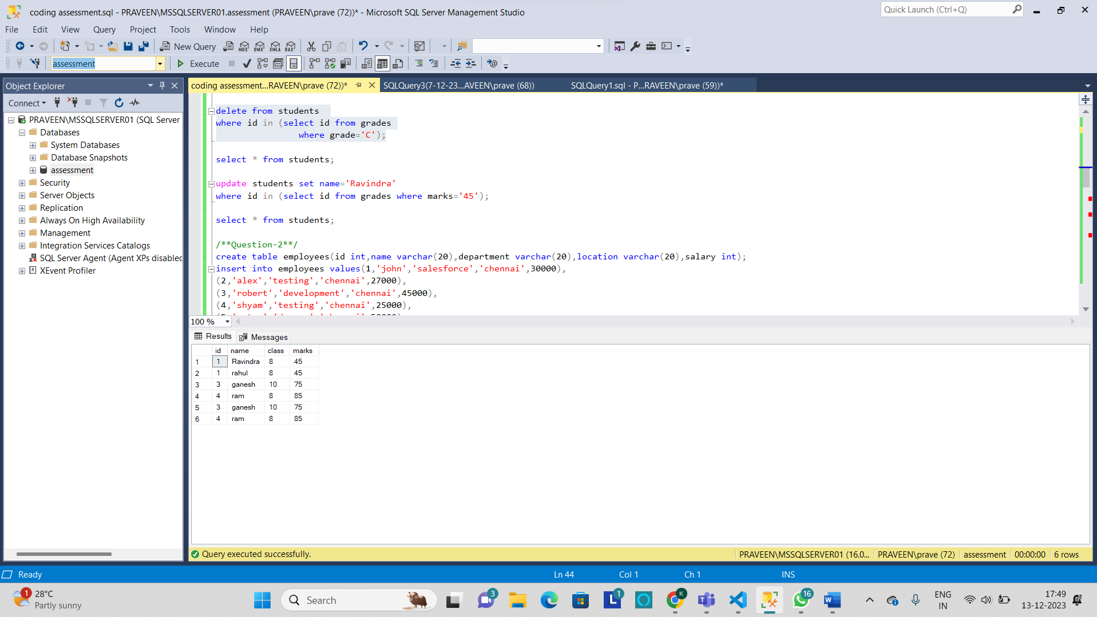

2. Manipulate data by using sql commands using groupby and having clause.

